PREMISE
In a decimated near-future, a family of

Have you ever wondered who was here before the world began? 13.8 billion years ago, there once lived an omnipotent being named Singularity who was the overprotective parent of six kids (HD, Cartwheel, Whirlpool, Triangulum, Andromeda, Milky Way), and their dog Gravity. The Galaxys lived in peace in a fortress in a cosmic forest. One eon, they get forced out of their quiet lives to save the Universe after their home gets destroyed and dark matter monsters are unleashed in a family separation event, known as the Big Bang. HD – a larger-than-life teen – with their dog Gravity must journey to the Edge of the Universe to unlock the mysteries of the past before the dark forces of the cosmos eat their family. The Galaxy Family is an animated musical adventure drama film and adaptation of David Quang Pham’s epic musical Ellipses, which had a sold-out Off-Broadway production and was written after his astrophysics undergrad. To learn their character designs in our treatment and script, visit TheGalaxyFamily.com.

SETTING
The Galaxy Family takes place throughout the entire span of the observable universe, and even the unobservable spaces too.
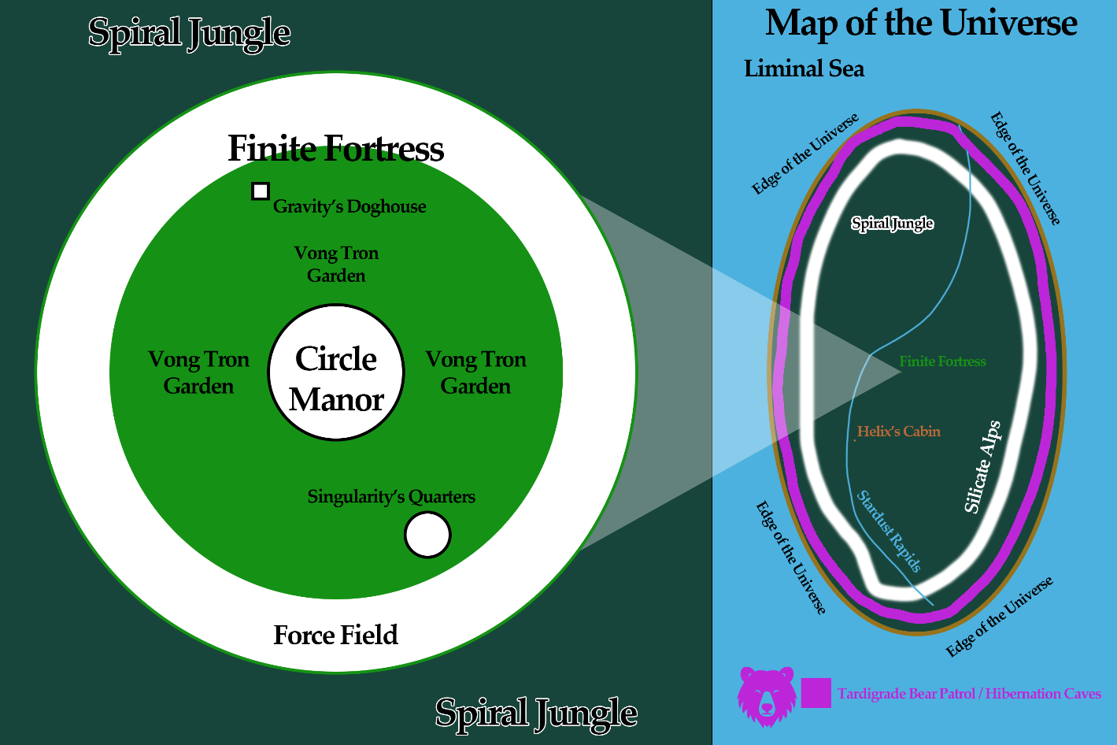
Their Universe
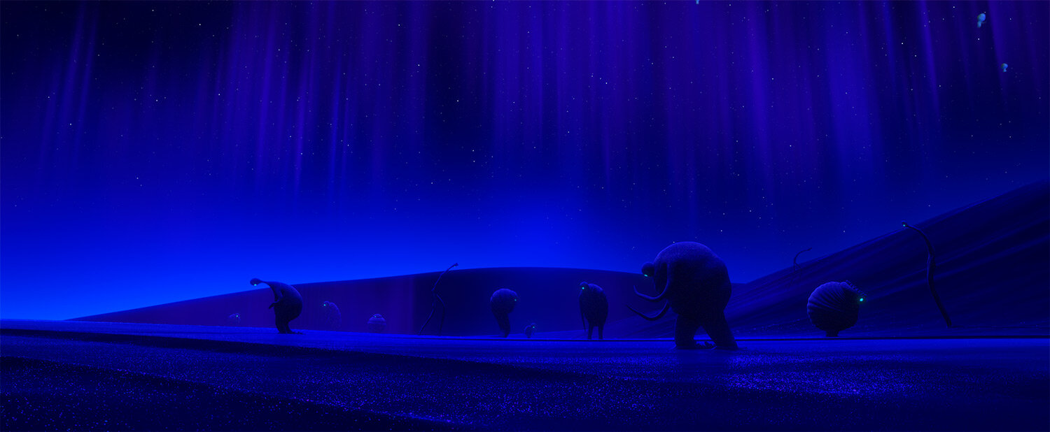
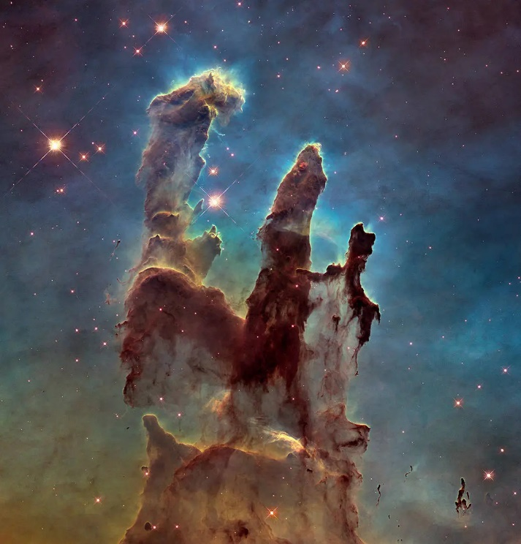
This world is like if you took the Pillars of Creation (left) and expanded it into a cosmic forest.

Worldbuilding Inspiration
The Flow Zone from Pixar’s Soul
(below in blue)
Disney’s Treasure Planet
(below & next page)

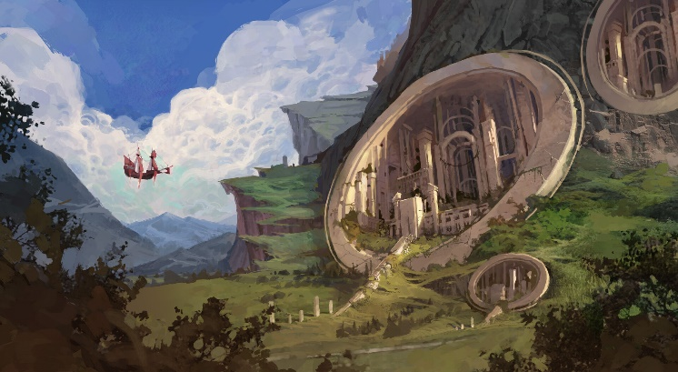
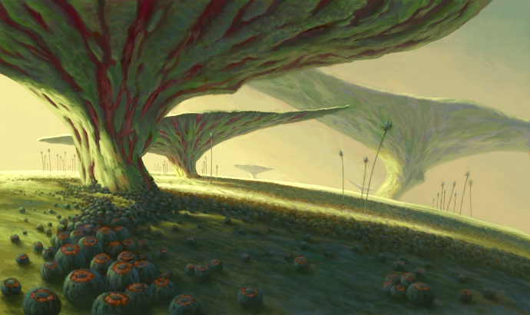

The Center of the Universe (Finite Fortress)
Circle Manor
- Andromeda’s Room
- Bowl Hall (Dining Hall)
- Hallway
- Kitchen
- Rooftop
Gravity’s Doghouse
Singularity’s Quarters
Vòng Tròn Garden
The Edge of the Universe
The Spiral Jungle
Helix’s Cabin
Silicate Alps
Silicate Valley
Stardust Rapids
Water Bear Caves
—Monos Keras’s Cave
The Sea of Liminality
Ellipsis
HD’s Home
The Oval Office
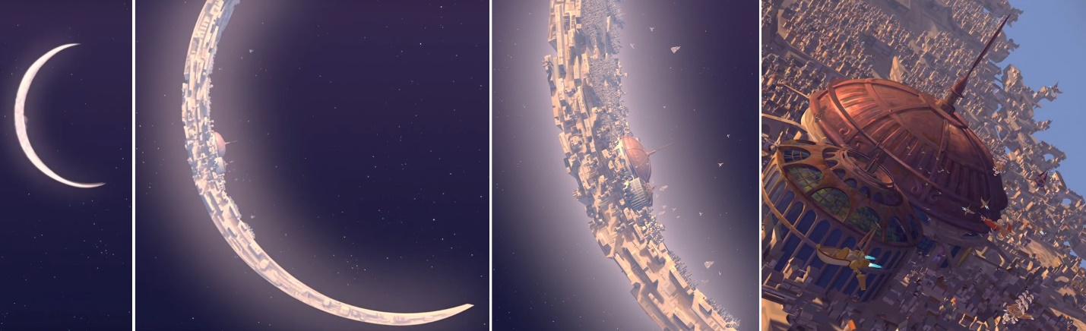

CHARACTERS
The Galaxy family resides in Finite Fortress at the Center of the Universe. Eons to a Galaxy are like years to a human. Singularity is the overprotective single parent of six. Their oldest child is HD (16). Their youngest is Milky Way (6). The rest are teenagers named Triangulum, Andromeda, and twins: Cartwheel and Whirlpool. The family dog is Gravity. Dual Protagonists: Gravity is the narrator, and HD is the star-studded main character. Helix is the main antagonist, an outsider trying to save their own world by stealing the Core Tam – the orb of infinite light at the Center of the Universe.
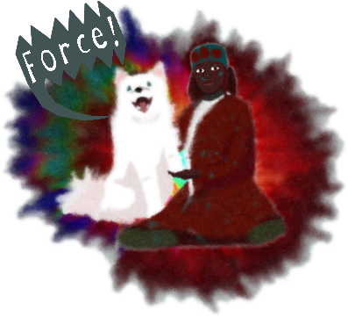
The Galaxy Family
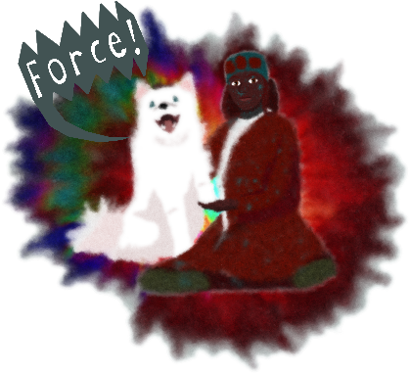
GRAVITY, 16 eons/32 dog-eons, is the family pet who narrates cause – like every dog – they stare out into space, knowing that someone is listening. Their parents were leaders of the tidal wolf pack in the outside world, so Gravity has wolflike instincts that results in their unruliness. Singularity named them ‘Gravity’ as “this dog lets everyone down.” Gravity has a vendetta against them for dognapping Gravity as a puppy, but they truly care about Singularity’s firstborn, HD. HD sees Gravity as equals and is the only person to speak their language. Together, they bring the house down to usher in a new cosmos without Singularity’s rule. But freedom has a cost: their friendship. On their journey, HD misses their family more and more which conflicts with this dog’s goal to return as the pack’s rightful leader. Gravity is meant to live up to their name as the fallen hero.
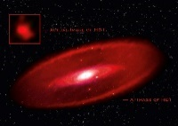

HD1, 16 eons, is Singularity’s firstborn and the only one who was born in the outside world before Singularity walled it off. HD is named after Singularity’s mom, Heidi, an explorer killed on an expedition to find the Center of the Universe. Upon discovering the Center, Singularity prevented HD and all future kids from escaping. Singularity can leave their fortress to scavenge but tasks HD with staying inside and looking after their younger siblings. Like the oldest sibling in every family, HD is overworked and feels unheard. It seems the only person who truly listens is their dog, Gravity. Gravity gives HD a new purpose in life and makes HD curious about the Edge of the Universe. When HD gets ahold of Singularity’s magical flintlock pistol called the “Big Bang” and explorer uniform, HD and Gravity run away. But when the journey is just them two, HD starts feeling guilty for abandoning their little siblings, which breaks their loyalty to Gravity.
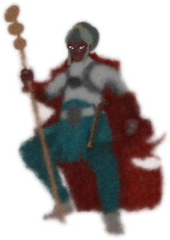
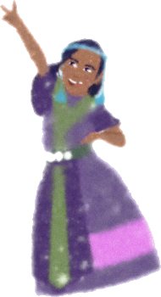
SINGULARITY, 36 eons, is a godly figure and beloved single parent who must protect their six children from the outside world. They come from a line of explorers, more so conquerors. Their parents set an expedition in search of the Center of the Universe but were killed in a retaliatory raid, not before giving Singularity a magical flintlock pistol called the “Big Bang.” With their cat Vat Ly, they were marooned and taken in by tidal wolves. The pack raised them to survive in the wilderness. Singularity soon vanished to give birth to HD, resulting in the pack leaders killing Vat Ly. In revenge, Singularity killed many in the pack and dognapped Gravity. They made countless enemies in their pursuit of the light in the Center of the Universe. Once they discovered it, they built a fortress to harness all its light, which plunged the cosmos into darkness. Their parents died while exploring worlds, so they fear their kids would develop that same passion for exploration and leave the safety of their fortress in the Center of the Universe.
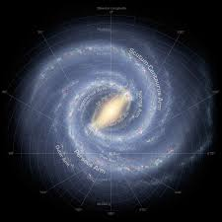
MILKY WAY, 6 eons, is Singularity’s youngest kid who is cute and silly, making them the family favorite. They learn a lot about the world through board games, coloring clay tablets in Singularity’s study, and letting their wild imagination roam free with their cloudy dolls named Magellan and Nic. If something happens to this little kid, you will not hear the end of it. That is the case when they go missing after the Big Bang, landing in a wilderness that’s perilous even for adults. Now, Milky Way must traverse these unexplored terrains that unravel new wonders and monsters from its darkness with nothing but their curiosity and compassion to shield them from harm’s way. This lovable and zealous yet naïve kid will become the unexpected hero this family needs.
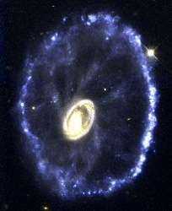
CARTWHEEL, teen, is Singularity’s fierce kid and Whirlpool’s troublemaking twin who solves things with violence. They are in shape with their gymnastic physique and ballerina’s cutthroat attitude. They are tense, insensitive, and cantankerous in their pursuit of beating their previous records. They fight using the “martial” in martial arts. Whirlpool is always by their side and balances their unkind personality out.
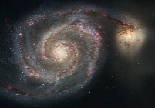
WHIRLPOOL, teen, is Singularity’s spiritual kid and Cartwheel’s troublemaking twin who finds solutions through meditation. They are the book-smart kid whose thought process can get very lucid. They are spiritual, sensitive, and mischievous in their goals of understanding the meaning of time. They fight using the “arts” in martial arts. Cartwheel is always by their side and balances their laid-back personality out.
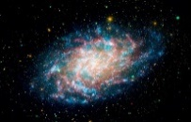
TRIANGULUM, teen, is Singularity’s goody-two-shoes kid who wants a normal life. Since they are a toady to Singularity from how they sing to how they behave like them, the other kids see Triangulum as a square. They have a poppy singing voice and often flaunt it when making the others perform sing-alongs. They are organized, snappy, and virtuous, so the other kids can rely on them as a leader when the cosmos spirals out of control. They just need to accept that there is no such thing as normality in this family.
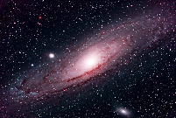
ANDROMEDA, teen, is Singularity’s kid who is often the comic relief. When they have nothing better to do, they go treasure hunting around the garden and pretend to be a pirate with their telescope. They are seafaring, wacky, and glamourous, especially if they can go out and sail the open space. After discovering that Singularity kept the cosmos in check by securing the five Spacetime Pearls, they set out to recollect these pearls to return the Universe back to stasis.
Antagonist Living in the Spiral Jungle
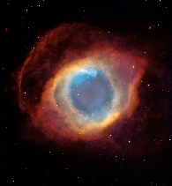
HELIX, 40s, is Singularity’s enemy-turned-love interest-turned-enemy. Helix was a raider who attacked the Relativity’s ship in the Liminal Sea. In the chaos, they were lost at sea until they stumbled upon Singularity, their mother Heidi, and cat Vat Ly. To build trust, they helped find land. When they reached the Universe, Heidi fell ill. Helix and Singularity took turns caring for Heidi and soon developed feelings. Unfortunately, Helix caught Singularity mercy-killing their mother. Helix shot Singularity with their crossbow and left them to die, before leaving the Universe on their makeshift ship. Eons later, they return when their world is facing an energy crisis. They seek the Core Tam, the orb of infinite light at the Center of the Universe. Helix lives in a cabin and hunts with their double-helix crossbow. Compared to the rural members of the Galaxy family, Helix is very tech savvy. They are the first feature film’s main antagonist.
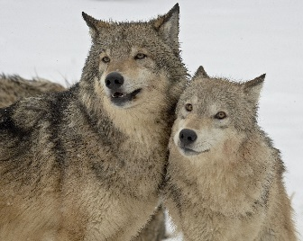
The Tidals (Wolves)
TIDAL WOLVES are wolves that personify tidal forces.
Bark: ”Force” Howl: ”Fall”
ANTI is the current disorganized leader of the wolf pack. They do not trust Gravity to take on the role long after their slain parents.
CHO and SOI are Gravity’s deceased parents who were leaders of the tidal wolf pack. Long ago, they took in a teenage Singularity and their cat Vat Ly when they were marooned and taught them how to survive in the wild. When Cho and Soi broke Singularity’s trust by starving Vat Ly to death during Singularity’s absence, Singularity killed them and stole away their pup. Cho and Soi named their pup ‘Mùa Thu’ (“Autumn” in Vietnamese), before Singularity claimed the puppy as ‘Gravity.’

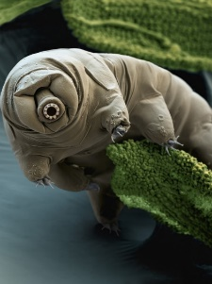
The Tardigrades (Bears)
MONOS KERAS is the legendary flying eight-legged water bear with a spiraling horn on their forehead who once dominated the Spiral Jungle. They also mortally wounded Heidi, Singularity’s mom, upon seeking shelter in their cave. When the tidal wolf pack took in young Singularity, the wolves became a thorn in Monos’s influence as the pack grew into an unstoppable force while Singularity slayed Tardigrade monsters. When Singularity plunged the forest into darkness, this forced all Tardigrades into eternal hibernation. In the feature, Singularity’s firstborn unleashes the Big Bang which revitalizes the Spiral Jungle and awakens Monos and the Tardigrades once more. In the sequel, they are the main antagonist out for vengeance against Singularity’s children.
TARDIGRADES are eight-legged water bears that patrol the Edge of the Universe. They are ruthless monsters that consume life, slaughtering everyone in their path.

Moss Pigs
ARDI is an orphaned moss piglet that Milky Way befriends.
MOSS PIGS are moss-skinned pigs.

Other Wild Creatures of Spiral Jungle
AQUILAS are birds of prey.
NOVA LIONS are cougars and predatory felines.
ORBITOADS are amphibians that croak “Orbit.”
TARANDUS are cosmic reindeer.
TIMSAHS are crocodile-like beasts in the waters.

The Relativitys
HEIDI, 40s, is Singularity’s mother and an explorer who was a special agent in the ultramodern world of Ellipsis. Like her husband Quan Su, she set an expedition to locate the Center of the Universe. Following a retaliatory raid that killed Quan Su and their crew, Heidi, her child, and their cat Vat Ly were the only survivors. They landed by the Edge of the Universe where Heidi soon fell ill. Singularity sheltered her in a cave which turned out to be a bear cave. While Singularity was away, Heidi was severely mauled by a legendary Tardigarde bear named Monos Keras. Singularity unwillingly performed a mercy killing with Heidi’s magical flintlock pistol known as the “Big Bang.” Singularity named their firstborn, HD, after Heidi.
QUAN SU, 40s, is Singularity’s father and an explorer who was a former general of the military in the ultramodern world of Ellipsis. Like his wife Heidi, he set an expedition to locate the Center of the Universe. Due to his warlord tactics, he was viewed often as a conqueror. During a retaliatory raid, he and almost all his crew were killed.

Milky Way’s Mind
Solar System are Milky Way’s imaginary friends that channel more mature thoughts.
○ SUN, MERCURY, VENUS, EARTH, MARS, JUPITER, SATURN, URANUS, NEPTUNE, PLUTO, CERES, ERIS, HAUMEA, MAKEMAKE
Other Imaginary Friends
○ BETELGEUSE, PROXIMA CENTAURI

Residents of Ellipsis
SPT0615-JD, 30s, is HD’s eventual partner.
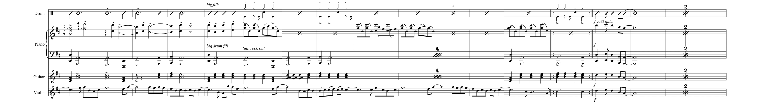
ABELL, twelve, is HD’s eventual child.

SELECT SONGS (from Ellipses)
Links in Blue
”Bounce”
”Crunch”
”Cutting Edge (Make Myself Clear)”
”Big Bang”
”Anomaly is Everything”
”Time is Relative”
”Warps, Waves, and Wrinkles”
”Globular”
”Parallax”
”Big Crunch”
”Big Bounce”

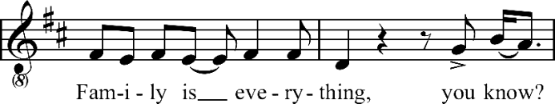
THEMES
The Galaxy Family presents the connections that science and the cosmos have with the human condition and family. The fantastical and mythical story explores the themes of existentialism, family dynamics, intergenerational trauma, harmony with nature, and the importance of connection, all woven through an epic lens where the perilous journey has the characters grow and love each other as a family to survive.
The features tell the story of Gravity the dog and their lifelong ‘human’ friend HD. The epic also follows Milky Way, the youngest child of Singularity.
Gravity is treated like a pet by the other members of the Galaxy family and with disdain by the guardian named Singularity. However, they know deep down that they are a wolf who belongs in the wild. They also love HD like family, which conflicts with their identity. Because of Gravity’s relationship with a human Galaxy, the tidal wolves do not trust Gravity. The last time the wolves took in and cared for a Galaxy (Singularity), Singularity killed the leaders of their pack (Gravity’s parents). However, much like the tale of Moses, Gravity leads their ‘people’ out of the darkness caused by Singularity. Gravity is afraid to let their friends down and hurts themself for it. However, it is okay to let ourselves down because how else would we appreciate the ups in our lives?
HD is alienated by their younger siblings, except Milky Way as they are too young to feel that way. Singularity puts the responsibility of caretaking on their firstborn child, HD. It leads to HD’s isolation and alienation from their siblings who do not see HD as a fellow kid, similar to Gravity with everyone in the household. The allurement of nature and wilderness also calls to HD. HD longs for freedom and yearns to experience the world beyond their confined space. They have a desperate wish to escape this solitary life at the Center of the Universe and explore the luscious forest until they reach the Edge of the Universe. HD does not desire maturity but the wild abandonment. This epic is about curiosity, exploration, hope, and self-discovery.
Milky Way is the most beloved member of the Galaxy family, mainly because they are a little child. Milky Way looks up to Singularity/Singsing and HD. When Singularity dies, HD disappears, their other siblings abandon them, their two dolls get destroyed, Milky Way journeys alone leading a blossoming friendship circle from their imaginary friends to the wild animals. They have the most emotional growth.
The Big Bang happened due to Singularity’s past actions and inactions that finally have consequences for their children. Gravity seeks revenge (to them: justice) on Singularity for murdering their parents and dognapping them as a puppy, before they could take the throne of the tidal wolf pack. Gravity is a hero to the wolves when Gravity manipulates HD into killing Singularity. However, Gravity is a fallen hero to HD.
HD shoots and kills Singularity, much like Singularity shot and killed one of their parents and indirectly got their other killed. It is fate that this generational tragedy keeps repeating with each generation.
The Galaxys made an enemy out of mother nature. This is relative to the conflict between humans and nature, especially land development. Singularity tore down the Spiral Jungle and took away its light to make their dense fortress. The kids will have to do the same in order to rebuild their fortress and any sort of shelter. In the astrophysics concept of accretion, this is a cosmic parallel to deforestation.
The expansion of the universe, based on Hubble’s Law where galaxies must move away from the center, examines the nature of power when a centralized government (Singularity) is eliminated. This leads to factions (Singularity’s teenage children). The twins Cartwheel and Whirlpool are for eliminating the threat (HD) and bringing upon authoritarianism on the adversarial wild creatures. Triangulum wants to return the cosmos to normalcy. Andromeda enjoys the lack of central power and is indifferent in how the Galaxys treat the nebulous creatures. This is the family’s own Big Bang. Milky Way is just a kid who simply wants the best for everyone and a hopeful future but has profound respect for nature. They believe in the significance of collective action, where they have to work together.
However, this leads to character development through conflict with each children’s own version of negativity and positivity clashing. They must confront their own fears and eventually learn to love each other because compared to the wilderness, family is the most familiar. When Cartwheel loses their limbs and Whirlpool loses their voice, they learn to focus on their personal attributes they initially ignored. Singularity could not teach them to love each other, but the lonely journey in the vast cosmos does. It is also about perseverance to overcome obstacles.
HD and Milky Way have a strong oldest-youngest sibling bond. What Milky Way learns most from HD is respect for nature. HD’s empathy and respectful relationship with Gravity and the wolves shows that humans should treat animals with respect. This helps Milky Way befriend an orphaned moss pig on their perilous journey. Unlike most of their siblings, Milky Way does not attack animals and only do so in defense.
Near the end, a pivotal moment occurs when HD willingly sacrifices themself to save their baby sibling Milky Way from Gravity’s army, demonstrating the depth of their love and prompting a transformation in the other siblings. Milky Way’s bond with Ardi and HD’s bond with Gravity are distinct levels of trust.
Even in eternity, life is short.

BEFORE THE EVENTS OF THE STORY
The Relativitys are a prominent family in Ellipsis, a cosmic Atlantis. Quan Su (alias General Relativity) leads the military while Heidi (alias Special Relativity) serves as a special agent. Heidi was born in Quadric, a neighboring world. On her last try to conceive a child after countless failed attempts, a stray kitten stood by Heidi’s side. She successfully delivers their only child, Singularity. They also adopt the good-luck black kitten, naming them Vat Ly. Singularity honors music, so they often go by “Singsing.”
A dozen eons later, Ellipsis faces an energy crisis that threatens to plunge their world into darkness. Quadric pools their reserves into the development of dimension-breaking flintlock pistols known as Big Bangs. Ellipses soon invades Quadric. Heidi gets her hands on a Big Bang prototype. They realize the Quadratics plan to use Big Bangs not as weapons but as flares to navigate the Sea of Liminality, where its dimensional currents have all explorers going in circles. The Quadratics are trying to locate “The Universe,” where there is infinite light at its Center known as the Core Tam. Once the two worlds form an economic union, they begin funding voyages, hiring the sharpest Quadratic scientists and well-rounded Elliptical personnel. The key expedition to the Center of the Universe is on a ship called the Oval, headed by Commander Quan Su Relativity.
A 15-eon-old Singularity tires of the food of Ellipsis and music of Quadric. They are curious about the outside world, so Vat Ly and they sneak onto the Oval. Special agent Heidi soon gets on the ship to find Singsing. And they all end up sailing through the Liminal Sea together. All the crews’ Big Bangs do not work in their magic. They are merely weapons. However, Heidi’s prototype can open portals and lead the team. On their adventures, the Oval confronts Trigon pirates from the Trigs, a Bermuda-esque world set in uncharted dimensions. They are instant foes and must continue evading them. As the Oval tightens security, Singsing misses their old life, having to always hear the discordant sounds of the Liminal Sea. It doesn’t help that Singsing can understand Vat Ly’s urges as well. Singsing asks their father to abandon the search for the Center. When Quan Su rejects Singsing’s plea, Singsing nabs Big Bang from Heidi and shoots out the steering wheel, shutting off power throughout the Oval. The Trigons go in for the attack after being alerted to their location. As the crew gets wiped out and Heidi gets injured in the raid, Quan Su puts her and Singsing in an escape sub, not before putting a warm explorer uniform on Heidi. Quan Su goes down with the ship.
Stranded in the Liminal Sea for ages, a wounded Heidi implores Singsing to end her life so Singsing can live off the last supplies. Just before Singsing could do this, another sub rams them. Helix, a Trigon, is about to raid it before Singsing holds Helix hostage. Helix agrees to help find Ellipsis from their knowledge of uncharted dimensions.
Helix instead has them crash-land on the Edge of the Universe. The people-less world angers Singsing. But the Universe is what Quan Su died to find. Time is running out as Heidi grows ill. Singsing and Helix shelter her around Spiral Jungle before going out to scavenge. While facing monsters in the Spiral, they develop feelings for one another. Heidi heals and is becoming herself again. For Heidi’s birthyear, Singsing sends Heidi to a cave they fondly decorated. Heidi gifts Quan Su’s explorer uniform to Singsing. Singsing soon fights Helix when they find out Helix secretly built a vessel to escape alone, and separate. Vat Ly rushes to Singsing with dire news. Singsing returns to the cave to find a Tardigrade bear – the legend Monos Keras. Singsing shoots Monos, who escapes. A gravely disfigured Heidi motions for Singsing to mercifully kill her. Singsing unwillingly takes their mom’s life. Unfortunately, Helix returns to reconcile only to see Singsing kill Heidi. With their double-helix crossbow, Helix shoots Singsing and escapes the Universe. Now the only person in the Universe, Singularity is truly alone.
The tidal wolf pack, led by Cho and Soi, are about to ambush Monos, their foe. Instead, they find Vat Ly and a wounded Singsing. The wolves threaten to eat them if they do not help them hunt. Raised by the wolves, Singsing grows knowledgeable in surviving the harsher environment. Singsing earns their respect especially when they take power away from Monos and their Tardigrade bear army.
After a considerable harvest in the cosmic spring, 20-eon-old Singsing experiences wild mood swings and hears a calling. They fall into deep hibernation. When they awaken at the start of the cosmic autumn, they give birth to their first child, who they named: HD1. Singularity names HD after their slain parent, Heidi. Cho and Soi have also given birth to a puppy and their next heir named Mùa Thu (“Autumn” in Vietnamese).
Singsing finds out the pack starved Vat Ly to death in their slumber. Singsing kills Cho, Soi, and the pack in retaliation. Singsing is about to kill Mùa Thu until HD expresses love for the pup and says their first words. Singsing dognaps Mùa Thu, stealing away the pack’s rightful leader. Singsing renames Mùa Thu as Gravity as “this dog lets the family down.” Gravity vaguely remembers Singsing’s wickedness to this millennia.
After roaming for ages, Singularity with their baby HD become the first people to reach the Center of the Universe. They deforest the Spiral to build Finite Fortress that walls off the Core Tam, the infinite light source of the Universe. They hog all the light from Core Tam, which transforms the surrounding cosmos from a luscious forest into a dark forbidden forest. This sends many beasts into deep hibernation. This is when Singsing becomes the Singularity the Universe comes to fear. Over time, Singularity gives birth to five more galaxies. Their parents died exploring worlds, so they fear their kids would develop that same passion for exploration and leave the safety of the Center of the Universe. So, it breaks Singsing’s heart that their firstborn HD seeks the Edge. Nearly twenty eons passed and we are now in the present story of Ellipses: The Galaxy Family.

PLOT SUMMARY
Prologue
In the cosmic Spiral Jungle, 21-eon-old explorer Singularity, with toddler HD on their back, roams. They come from a line of explorers. Their parents set an expedition in search of the Center of the Universe but were killed in a retaliatory raid, not before giving Singularity a magical flintlock pistol called the “Big Bang.” They stumble upon an orphaned tidal wolf pup. HD wouldn’t stop crying unless they took in this pup. They name them Gravity for “always letting everyone down.” After drifting for ages, Singularity and HD become the first people to reach the Center of the Universe. They build Finite Fortress that walls off the Core Tam, the Universe’s infinite light source. They hog all its light, which transforms the surrounding cosmos into a dark forbidden forest. This sends many beasts into deep hibernation. This is when the Universe comes to fear Singularity. Over time, Singularity births five more galaxies: Cartwheel, Whirlpool, Triangulum, Andromeda, and Milky Way (“The Center of the Universe”).
Act I
Sixteen eons later, Singularity prepares a birthyear party for Milky Way, who is turning six. Singularity tasks 16-eon-old HD with distracting Milky Way. Singularity is going outside the fortress to scavenge for ingredients for the birthyear cake. HD still wonders why they couldn’t join them in scavenging. After all, HD is the only kid born in the outside world. All Singularity could do again is warn them of the dangers.
HD and Milky Way play the Moss versus Water board game, which sends them on an imaginative adventure. Meanwhile, Singularity wanders the Spiral, gathering fruits and cosmic eggs. They find an arrow that reminds them of an old love interest-turned-foe. They soon confront 36-eon-old Helix, who seeks the Center of the Universe. They shoot at Helix and run off, alerting nearby wolves. Before they could close the fortress, HD and Milky Way notice the beasts and Helix shoot a double-helix arrow that flies off and lands near Gravity. Gravity investigates. They hear the outside howls, triggering their wolflike instincts. They unexpectedly attack Singularity. HD stops them as they howl about the Edge of the Universe. Singularity banishes them to their cramped doghouse.
Later in the kitchen, Singularity and HD cook up the birthyear cake. Singularity and HD are the only two who can cook for their family, as HD is old enough to handle such equipment. HD is fascinated by the edge of the cake while Singularity stresses the importance of center. Singularity sees HD as a surface-level teenager. HD wants to explore the Edge of the Universe, angering Singularity (“The Edge of the Universe”).
Then, Milky Way’s birthyear party begins. They blow out all candles but one. They openly wish to explore the outside world, which scares Singularity. They warn them of its perils. The kids fight. Singularity unites them in a prayer (”Crunch”). HD steps out to give Gravity a piece of the cake. Gravity coughs up the Big Bang pistol, shocking HD.
Meanwhile, Milky Way promises to drop their wish if they see Singularity’s study. Milky Way comes with Singularity to their quarters. Curious about an old clay figure of Singularity with their explorer parents, they reveal to Milky Way that everyone has ancestors, including the first person in the whole Universe.
HD is about to return the gun to Singularity, when they overhear them insult Gravity and mock HD’s curiosity of the outside world. HD steals Singularity’s explorer uniform and Andromeda’s telescope. On the roof, HD shoots a lightning storm out of the gun. Singularity catches sight of the storm and notices their gun and uniform are missing. HD sees a new world out there. Singularity has Milky Way stay put. Just as they exit their quarters, Gravity picks a fight with Singularity until Singularity gets the upper hand. HD stops them. The other kids come out to investigate. When asked, HD slides the gun to Singularity. Gravity tries to stop them from regaining it. Singularity threatens to put down Gravity. HD must now make a life-changing decision.
HD takes back the gun and shoots Singularity in the heart, which erupts light. Singularity dies in Milky Way’s arms. Suddenly, the garden withers. The lone candle from Milky Way’s cake drops to the floor. The manor goes up in flames. The wall collapses. Core Tam releases light out to the Spiral. The jungle returns to its previous state as a lush and bright forest before Singularity’s influence. Gravity and HD escape to the light, leaving behind their little siblings in ruins without a guardian (”Big Bang”).
Act II
At first, HD and Gravity have the time of their lives traversing the unexplored terrains. When they get caught in a storm, they find shelter in a cabin. It turns out to be Helix’s cabin, who captures them. Back at home at the Center of the Universe, the kids give Singularity a proper burial. Wildlife surrounds them like never before. Triangulum organizes a team to go out to search for HD and Gravity (them and Andromeda) and a team that stays (Cartwheel, Whirlpool, and Milky Way). HD remembers how to do the ceremonial dance to harness the light of Core Tam. Triangulum tries to raise their morals by reminding them that family is everything (“Anomaly is Everything”).
Elsewhere, HD and Gravity learn from Helix that Singularity shot their own mother. They turn the situation around and corner Helix, who reveals they come from another world, Singularity was born in Ellipsis, and that their ship is docked at the Edge. Gravity falls for a booby trap that injures them. HD sets Helix’s cabin on fire as reprisal.
HD shelters Gravity in a cave while HD scavenges. A legendary Tardigrade bear named Monos Keras comes out of hibernation. They do not harm Gravity. Instead, they plant a distrust of galaxies within them.
Cartwheel and Whirlpool confront Helix, heartbroken by their destroyed cabin. Helix supplies the twins with weapons. They go after HD. Gravity and HD play fetch to celebrate HD’s 18th eon. HD misses their family. However, Gravity assures HD there is no point of return (“Far-Fetch”). They soon get ambushed by Cartwheel and Whirlpool. They defeat Cartwheel and Whirlpool.

They reach the Edge, where HD is dissatisfied. Now that Gravity has done what they promised for HD, Gravity will go find their wolf pack. When Gravity connects with the pack, they overcome many physical trials that earn their respect. However, they realize that Gravity has befriended HD who reminds them of Singularity. The only way to win their trust is for the final trial: to kill HD. Gravity objects.
With Gravity’s pack disowning them and HD’s family likely to never forgive them, tensions run high. Milky Way nearly reaches the Edge, only to confront a Tardigrade bear. Milky Way’s scream attracts HD’s attention. HD goes to find Milky Way,
Act III
Following their epic fight, HD guiltily falls off the sea cliff that overlooks the Edge of the Universe. HD
They both see visions of their parents. Singularity tells HD that their path as an explorer made them proud. Cho and Soi tell Gravity that they are a lone wolf that will eventually find their pack. HD awakens to see Gravity raise them up out of dimensional waters. They confess they need time apart. Gravity runs off into the jungle. Milky Way soon finds HD. They will never forgive HD but are grateful to not lose more family members. HD acknowledges that they are a wanted criminal. Milky Way assures them that they are independent and do need HD’s care anymore. With help from wildlife creatures, Milky Way locates Helix’s ship and HD sets sail off the Edge of the Universe, not before handing them the Big Bang pistol. The other siblings joyfully find Milky Way. They reveal the Big Bang, which has them assuming HD fell off the face of the Universe.
One eon later, the Galaxy kids rebuild a more open home at the Center of the Universe. Gravity’s howls are heard far and wide in the cosmos. The family visits Singularity and reflects that their light could not be contained and that it was finally freed (“Family is Everything”). Elsewhere, HD arrives at Ellipsis, a cosmic Atlantis.
The sequel is Galaxy Family 2: The End of the Universe.

SCIENCE EDUCATION IS IMPORTANT
The knowledge of science is important because it cultivates critical thinking skills by encouraging curiosity, questioning, and evidence-based analysis, allowing individuals to better understand the world around them, make informed decisions, and solve problems through a methodical approach. It also fosters creativity and adaptability to change. Think critically and approach challenges with a scientific mindset.

THE SPACE AGE HAS RETURNED
The "Space Age" is experiencing renewed popularity due to a "New Space Age" marked by increased accessibility and commercialization of space travel, driven by significant technological advancements, lower launch costs, and the involvement of private companies, which has opened up opportunities for space tourism, satellite internet, and more, capturing public interest and imagination beyond just government-led space exploration; essentially making space more relevant to everyday life.

SCI-FI IS (MORE) POPULAR NOW
Science fiction is gaining popularity due to advancements in the growing relevance of real-world technological developments reflected in sci-fi narratives, special effects technology allowing for more immersive worlds on screen, and its ability to explore complex societal issues through futuristic settings, making it a powerful tool for social commentary. Sci-fi often addresses current societal anxieties about technology, climate change, and political issues, making it more engaging to contemporary audiences.

SCIENCE AND MUSIC GO TOGETHER
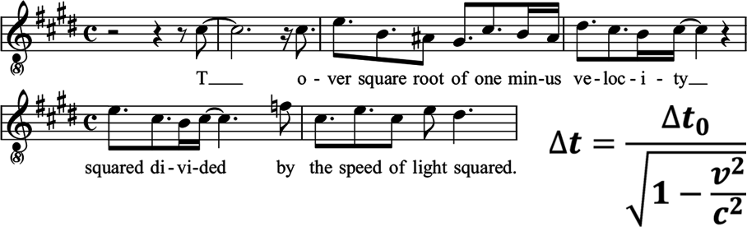
A Little Astrophysicist’s Dream
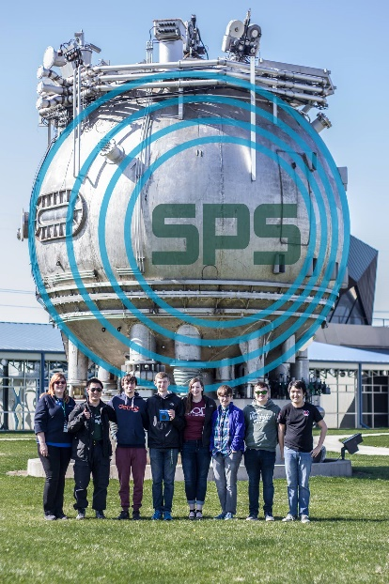
When 7-year-old David Quang Pham attended Space Camp, he saw life not only on Mars but in Mars. During his astrophysics undergrad (B.S. 2018), he saw lives in galaxies. Galaxies are lost children wandering through the unknown after a family separation event known as the Big Bang.
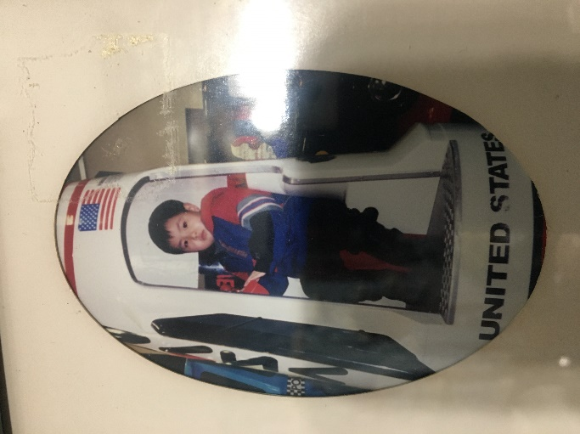

David at 7 years old in Space Camp,
Huntsville, Alabama

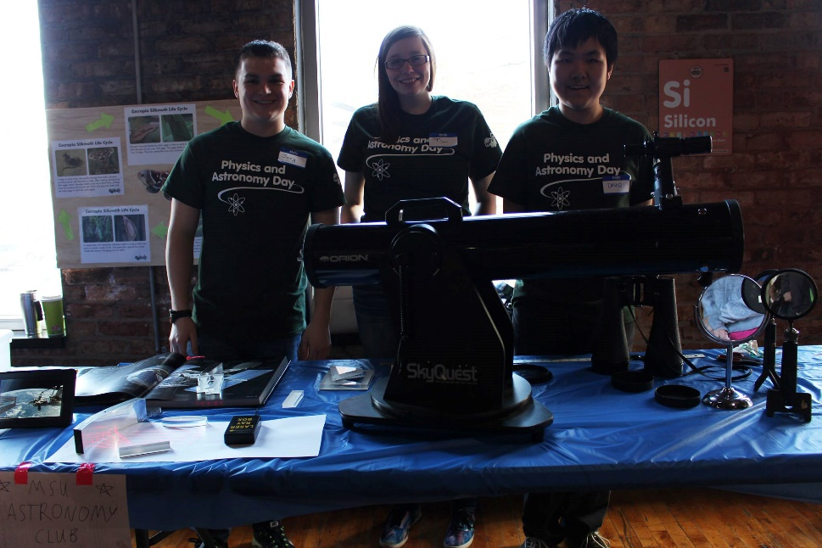
David was the VP of Michigan State’s chapter of Sigma Pi Sigma, honor society for physics and astronomy; and volunteer at Impression 5 Science Center in East Lansing.
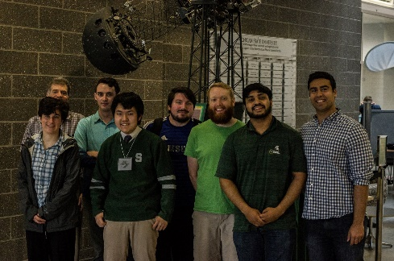
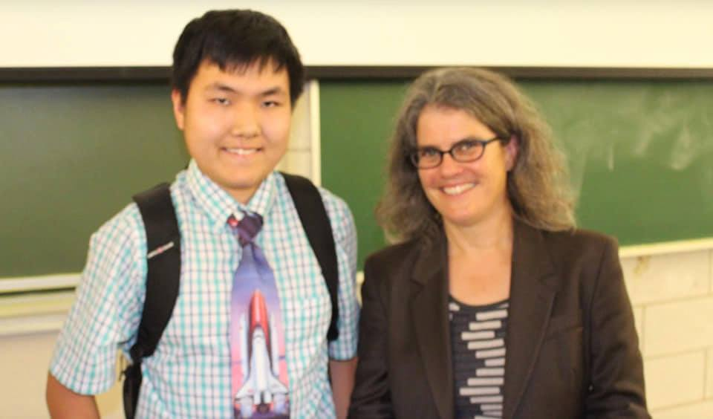

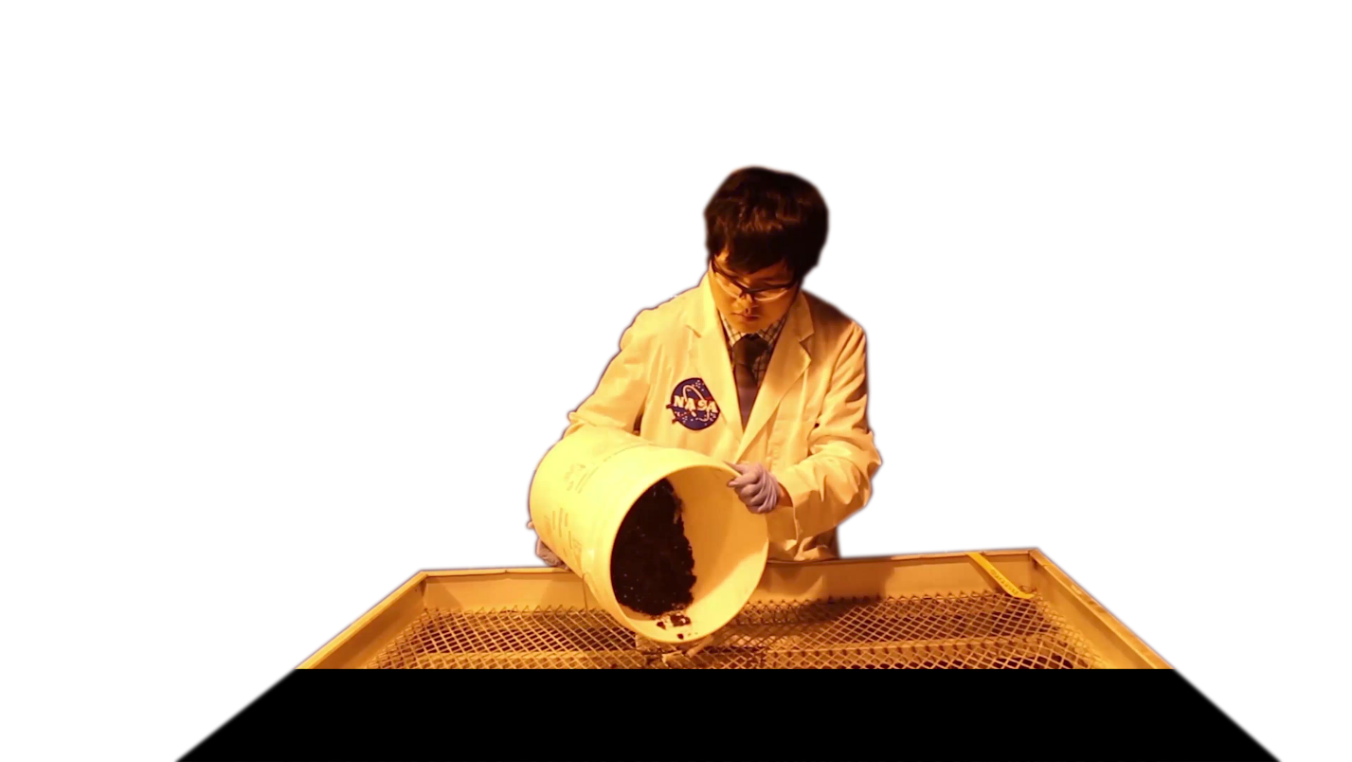
Andrea M. Ghez
Nobel Prize in Physics 2020
David studying in guest Dr. Ghez’s class in 2015.

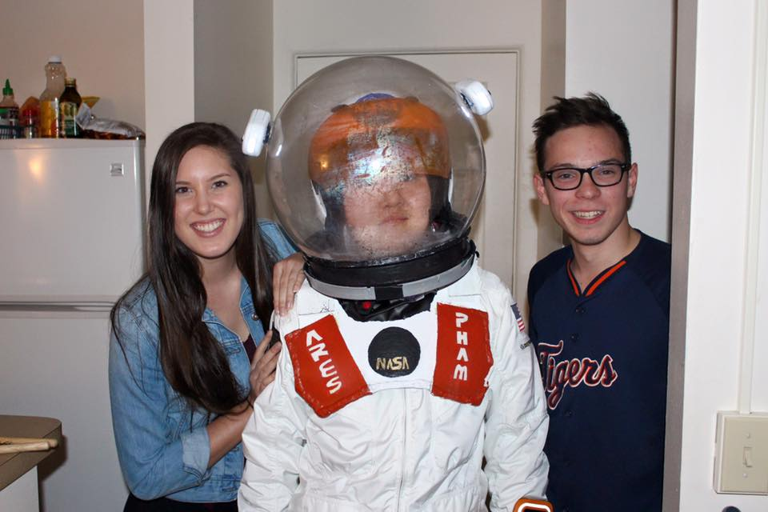
David ran a greenhouse
in his sophomore and
junior year, testing botanical
interactions in a vacuum.


THE GALAXY FAMILY
Treatment & Script Preview
TheGalaxyFamily.com

Based on the musical Ellipses
by David Quang Pham




Contact:
616 818 5413
davidquangpham@outlook.com
512 W 158th St #2 New York, New York 10032
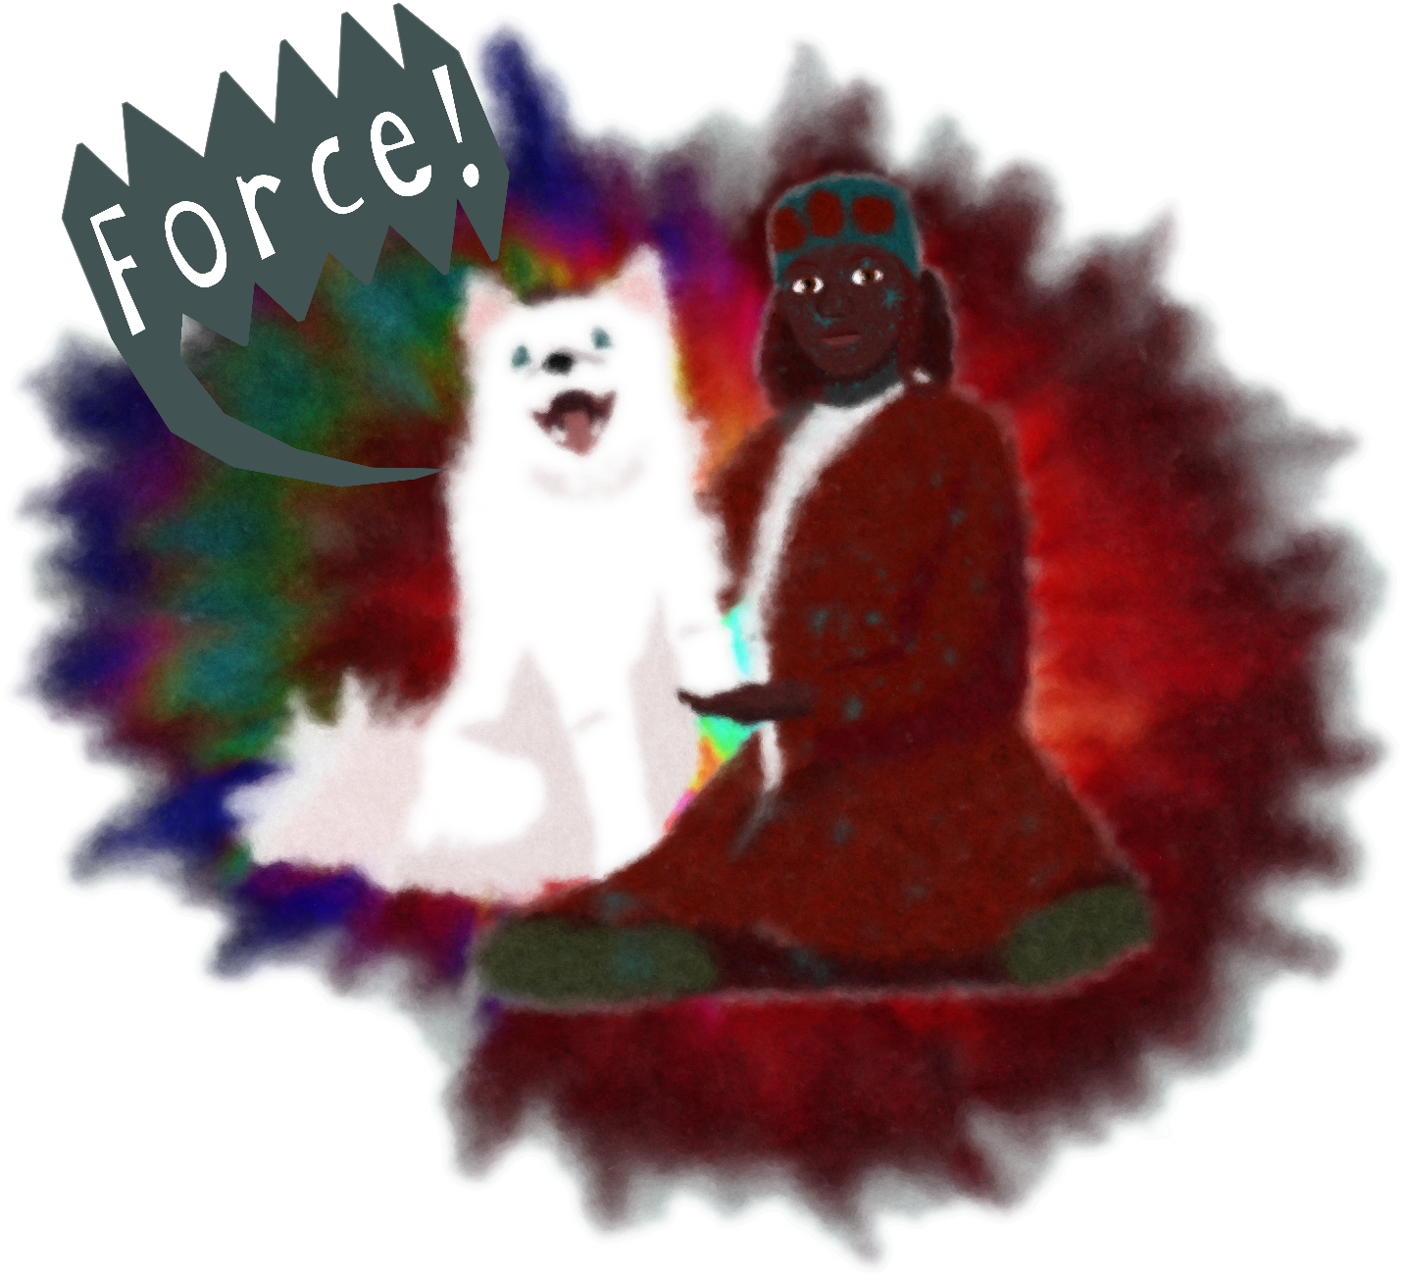

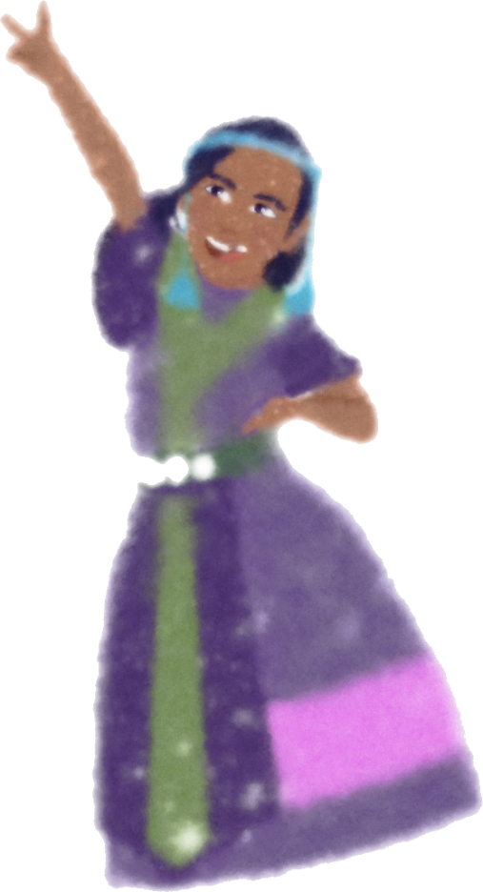

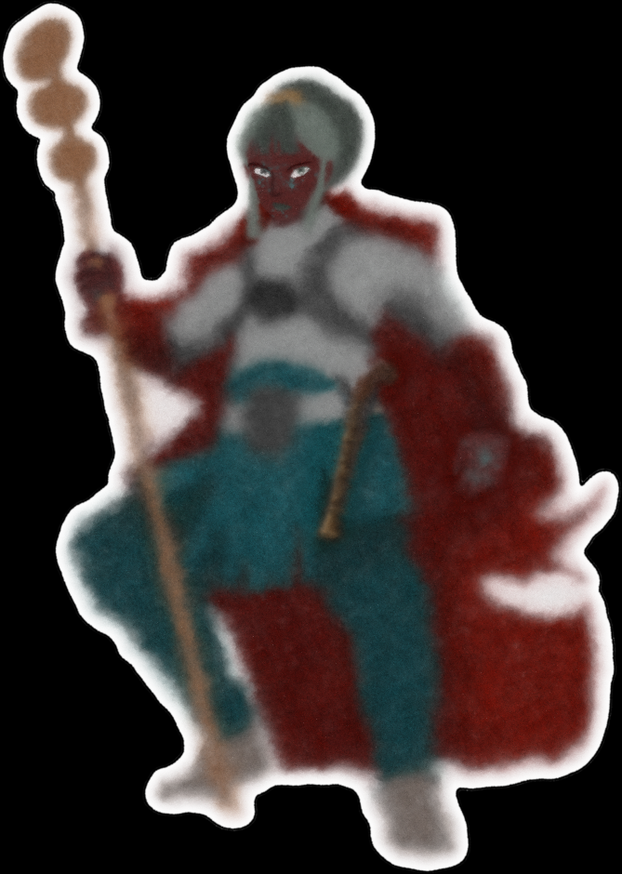
GRAVITY AND HD
MILKY WAY Main Characters
Major Character Artist: David Quang Pham
Artist: David Quang Pham

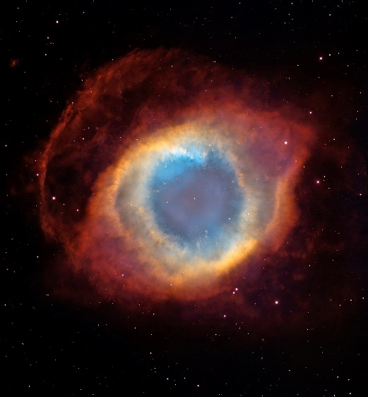
SINGULARITY
Major Character
Artist: David Quang Pham
HELIX
Antagonist
Character Design in Process

